 | 
HIGH PERFORMANCE TRUNCATED MULTIPLIER FOR IMAGE PROCESSING APPLICATION
A MINOR PROJECT – I REPORT
Submitted By
JANAPRIYA R (927621BEC067)

BACHELOR OF ENGINEERING
in

DEPARTMENTOF ELECTRONICS AND COMMUNICATION ENGINEERING
M.KUMARASAMY COLLEGE OF ENGINEERING
(Autonomous)

KARUR – 639 113
DECEMBER 2022
M.KUMARASAMY COLLEGE OF ENGINEERING, KARUR
BONAFIDE CERTIFICATE
Certified that this project report “HIGH PERFORMANCE TRUNCATED MULTIPLIER FOR IMAGE PROCESSING APPLICATION” is the bonafide work of “MONIKA G (21BEC127), JANAPRIYA R (21BEC067), KARTHIKA R (21BEC074)” who carried out the project work under my supervision in the academic year 2022-2023.

SIGNATURE | SIGNATURE
Dr.S.PALANIVELRAJAN,M.E.,M.B.A.,Ph.D.,D.litt(USA).,  HEAD OF THE DEPARTMENT  PROFESSOR  Department of Electronics and Communication Engineering,  M.Kumarasamy College of Engineering, Thalavapalayam, Karur-639113. | Dr.K. SIVANANDAM, M.E., Ph.D.,  Assistant Professor  Department of Electronics and Communication Engineering,  M.Kumarasamy College of Engineering,Thalavapalayam,  Karur-639113.

This project report has been submitted for the 18ECP103L-Minor Project I Viva Voce Examination held at M.Kumarasamy College of Engineering, Karur on ______________.

PROJECT COORDINATOR

Vision and Mission of the Institute and Department

Vision
To emerge as a leader among the top institutions in the field of technical education.
Mission
- Produce smart technocrats with empirical knowledge who can surmount the global challenges.
- Create a diverse, fully-engaged, learner-centric campus environment to provide quality education to the students.
- Maintain mutually beneficial partnerships with our alumni, industry and professional associations.

Department of Electronics and Communication Engineering
Vision
- To empower the Electronics and Communication Engineering students with Emerging Technologies, Professionalism, Innovative Research and Social Responsibility.
Mission
- Attain the academic excellence through innovative teaching learning process, research areas & laboratories and Consultancy projects.
- Inculcate the students in problem solving and lifelong learning ability.
- Provide entrepreneurial skills and leadership qualities.
- Render the technical knowledge and skills of faculty members.

PROGRAM EDUCATIONAL OBJECTIVES (PEO'S)

- PEO1: Graduates will have a successful career in academia or industry associated with electronics and communication engineering.
- PEO2: Graduates will provide feasible solutions for the challenging problems through comprehensive research and innovation in the allied areas of electronics and communication engineering.
- PEO3: Graduates will contribute to the social needs through lifelong learning, practicing professional ethics and leadership quality.

PROGRAM OUTCOMES(PO'S)
- PO1: Engineering knowledge: Apply the knowledge of mathematics, science, engineering fundamentals, and an engineering specialization to the solution of complex engineering problems.
- PO2: Problem analysis: Identify, formulate, review research literature, and analyse complex engineering problems reaching substantiated conclusions using first principles of mathematics, natural sciences, and engineering sciences.
- PO3: Design/development of solutions: Design solutions for complex engineering problems and design system components or processes that meet the specified needs with appropriate consideration for the public health and safety, and the cultural, societal, and environmental considerations.
- PO4: Conduct investigations of complex problems: Use research-based knowledge and research methods including design of experiments, analysis and interpretation of data, and synthesis of the information to provide valid conclusions.
- PO5: Modern tool usage: Create, select, and apply appropriate techniques, resources, and modern engineering and IT tools including prediction and modelling to complex engineering activities with an understanding of the limitations.
- PO6: The engineer and society: Apply reasoning informed by the contextual knowledge to assess societal, health, safety, legal and cultural issues and the consequent responsibilities relevant to the professional engineering practice.
- PO7: Environment and sustainability: Understand the impact of the professional engineering solutions in societal and environmental contexts, and demonstrate the knowledge of, and need for sustainable development
- PO8: Ethics: Apply ethical principles and commit to professional ethics and responsibilities and norms of the engineering practice
- PO9: Individual and team work: Function effectively as an individual, and as a member or leader in diverse teams, and in multidisciplinary settings
- PO10: Communication: Communicate effectively on complex engineering activities with the engineering community and with society at large, such as, being able to comprehend and write effective reports and design documentation, make effective presentations, and give and receive clear instructions
- PO11: Project management and finance: Demonstrate knowledge and understanding of the engineering and management principles and apply these to one’s own work, as a member and leader in a team, to manage projects and in multidisciplinary environments
- PO12: Life-long learning: Recognize the need for, and have the preparation and ability to engage in independent and life-long learning in the broadest context of technological change.

PROGRAM SPECIFIC OUTCOMES(PSO'S)
- PSO1: Applying knowledge in various areas, like Electronics, Communications, Signal processing, VLSI, Embedded systems etc., in the design and implementation of Engineering application.
- PSO2: Able to solve complex problems in Electronics and Communication Engineering with analytical and managerial skills either independently or in team using latest hardware and software tools to fulfil the industrial expectations.

MAPPING OF PROJET WITH POs AND PSO

KEYWORDS | Matching with POs , PSOs
Approximate Computing, Appromiate Multiplier , Truncation ,Computer Arithmetic | PO1, PO3,PO5, PO9, PSO1

ABSTRACT

Multiplier is one of the essential elements for microprocessors, digital signal processors etc. In this project, we had proposed architecture for high-speed Truncation Multiplier. In modern VLSI technology, the occurrence of all kinds of errors has always to be expected. There are some applications which accept small errors such as image processing. Designing accurate circuit for these applications is waste of area/power. Therefore, data computation time is reduced in the detector based truncated multiplier that supports full range and half range input data. The detector result is used to select the operand with full range input data for truncated multiplication. So, it reduces the switching activities in logic gates and proportionally reduces the power consumption. In this paper, we designed and implemented a new high-speed multiplier. We implemented 8-bit multiplier reduces the partial product array due to which the area is minimized. This reduction in partial product increases the speed of the multiplier. The proposed multiplier is designed and implemented using ALTERA STARTER ModelSim version 6.4a and XILINX Vivado ISE version 14.7. Experimental results demonstrate that the proposed 8-bit approximate multiplier is 20.74% faster and 40.83% area efficient than conventional 8-bit signed multiplier.

Table of Contents

Chapter No. | Particulars |  | Page No.
 | Vision and Mission of the Institute and Department |  | 3
 | POs, PSOs of the Department |  | 4
 | Mapping of project with POs and PSOs |  | 5
 | Abstract |  | 7
 | List of Figures |  | 9
 | List of Tables |  | 10
 | Acronyms/List of Abbreviations |  | 11
1 | Introduction |  | 12
 | 1.1 | Background | 12
 | 1.2 | Problem Statement | 13
 | 1.3 | Objectives | 13
2 | Literature Review |  | 14
3 | Project Methodology |  | 16
 | 3.1 | Existing Method | 16
 | 3.2 | Proposed Method | 16
4 | Results and Discussion |  | 20
5 | Conclusion |  | 23
 | References |  | 24

List of Figures

Figure No | Figure Name | Page No
3.1 | Partial product matrix of an 8-bit multiplier | 18
3.2 | Device Utilization Summary | 18
4.1 | Result | 21
4.2 RTL schematics of proposed multiplier 21
4.3 Fadd_new schematics multiplier 22
4.4 Analysis of truncated multiplier 22

List of Tables

Table No | Table Name | Page No
1 | Device Utilization Summary | 20

Acronyms/List of Abbreviations

Acronym | Abbreviations
CNN | Convolutional Neural Network
ISE | Integrated Synthesis Environment
MSB | Most Significant Bit
MSE | Mean Squared Error

CHAPTER 1
INTRODUCTION

High speed data processing and low power consumption are the most important parameter need to consider in many embedded systems, digital signal processing systems and wireless sensor network-based image processing applications. The multiplication processing unit play major role in most of the signal processing and image processing application systems and multipliers dominated the system performance and power consumption. In real time image-based applications, number of bit representation of the pixel in the image is increased to improve the quality of the image. So, data length and number of bits to be processed in the computation unit are increased. As a result, it increases the power consumption and affects the system performance in terms of computation time. In the data representation part, redundant bits are present due increased in the number of bit representation. Mostly, it is unavoidable because of high quality and high accuracy data representation is needed in the real time applications. But during the data processing in the arithmetic unit redundant data bits are not affect the final result and accuracy. So, we focused in the processing unit, to improve the efficiency of the system. This is used to multiplying the two numbers by vertically and cross wise. This method is used for the multiplication of two numbers in very less time. The detector unit is implemented in floating point multiplier and performance is analysed.
1.1 Background
Approximate multipliers can be constructed with different approaches, including scaling the supply voltage, truncating some partial product rows, designing the simplification multiplier equations, and using the approximate compressors to reduce the number of partial products rows. Voltage scaling technique was used to control the supply voltage of the logic gates, which helped reduce the power consumption. If the supply voltage was lower than the required nominal voltage, timing violation would occur, resulting in approximate results. However, if timing violation happened in critical paths, the erroneous value might be violation happened work designed approximate compressors modified from the accurate 4-2 compressor. The details of the accurate and approximate compressors are described in the next subsection.

1.2 Problem Statement
In many signal processing problems such as lossy
compression of images, sounds and films, the results of
using approximation computations and precise
computations have no significant difference from the
user’s point of view. JPEG, MP3 and MPEG are some
well-known algorithms for the mentioned lossy
compression problems. Each of these algorithms makes
some distortion on the original file in order to achieve a
better compression ratio. This amount of distortion of an
image, sound or film is usually ignorable from the user’s
viewpoint. In such problems, approximate computations
can be used instead of precise computations to reduce the
number of transistors, power consumption or delay.
In many signal processing problems such as lossy
compression of images, sounds and films, the results of
using approximation computations and precise
computations have no significant difference from the
user’s point of view. JPEG, MP3 and MPEG are some
well-known algorithms for the mentioned lossy
compression problems. Each of these algorithms makes
some distortion on the original file in order to achieve a
better compression ratio. This amount of distortion of an
image, sound or film is usually ignorable from the user’s
viewpoint. In such problems, approximate computations
can be used instead of precise computations to reduce the
number of transistors, power consumption or delay.
In many signal processing problems such as lossy compression of images, sounds and films, the results of using approximation computations and precise computations have no significant difference from the user’s point of view. JPEG, MP3 and MPEG are some well-known algorithms for the mentioned lossy compression problems. Each of these algorithms makes some distortion on the original file in order to achieve a better compression ratio. This amount of distortion of an image, sound or film is usually ignorable from the user’s viewpoint. In such problems, approximate computations can be used instead of precise computations to reduce the number of transistors, power consumption or delay.

1.3 Objectives

Multiplier is one of the essential element for microprocessors, digital signal processors etc. In this project, we had proposed architecture for high speed Truncation Multiplier. In modern VLSI technology, the occurrence of all kinds of errors has always to be expected. There are some applications which accept small errors such as image processing. Designing accurate circuit for these applications is waste of area/power. Therefore, data computation time is reduced in the detector based truncated multiplier that supports full range and half range input data. The detector result is used to select the operand with full range input data for truncated multiplication. So, it reduces the switching activities in logic gates and proportionally reduces the power consumption. In this paper, we designed and implemented a new high speed multiplier. We implemented 8-bit multiplier reduces the partial product array due to which the area is minimized. This reduction in partial product increases the speed of the multiplier

CHAPTER 2
LITERATURE REVIEW

2.1 TITTLE: HIGH PERFORMANCE 8-BIT APPROXIMATE MULTIPLIER USING NOVEL 4:2APPROXIMATE COMPRESSORS FOR FAST IMAGE PROCESSING
AUTHOR: Fatemeh Ranjbar, Yahya Forghani1, Davoud Bahrepour
YEAR: 2018
DISCRIPTION
In many signal processing problems such as lossy compression of images, sounds and films, the results of using approximation computations and precise computations have no significant difference from the user’s point of view. JPEG, MP3 and MPEG are some well-known algorithms for the mentioned lossy compression problems. Each of these algorithms makes some distortion on the original file in order to achieve a better compression ratio. This amount of distortion of an image, sound or film is usually ignorable from the user’s viewpoint. In such problems, approximate computations can be used instead of precise computations to reduce the number of transistors, power consumption or delay. Approximate addition and approximate multiplication are some aspects of approximate computations. In some approximate adders and approximate multipliers were studied and analyzed, elaborately.
2.2 TITTLE: NEW METRICS FOR THE RELIABILITY OF APPROXIMATE AND PROBABILISTIC ADDERS
AUTHOR: Jinghang Liang, Jie Han, F. Lombardi
YEAR: 2013
DISCRIPTION
Addition is a fundamental function in arithmetic operation; several adder designs have been proposed for implementations in inexact computing. These adders show different operational profiles; some of them are approximate in nature while others rely on probabilistic features of nanoscale circuits. However, there has been a lack of appropriate metrics to evaluate the efficacy of various inexact designs. In this paper, new metrics are proposed for evaluating the reliability as well as the power efficiency of approximate and probabilistic adders. Reliability is analyzed using the so-called sequential probability transition matrices (SPTMs). Error distance (ED) is initially defined as the arithmetic distance between an erroneous output and the correct output for a given input. The mean error distance (MED) and normalized error distance (NED) are then proposed as unified figures that consider the averaging effect of multiple inputs and the normalization of multiple-bit adders. It is shown that the MED is an effective metric for measuring the implementation accuracy of a multiple-bit adder and that the NED is a nearly invariant metric independent of the size of an adder.
2.3 TITTLE: DESIGN AND ANALYSIS OF AREA AND POWER EFFICIENT APPROXIMATE BOOTH MULTIPLIERS
AUTHOR: Suganthi Venkatachalam, Elizabeth Adams,Hyuk Jae Lee,Seok-Bum Ko
YEAR: 2019
DISCRIPTION
Approximate computing is an emerging technique in which power-efficient circuits are designed with reduced complexity in exchange for some loss in accuracy. Such circuits are suitable for applications in which high accuracy is not a strict requirement. Radix-4 modified Booth encoding is a popular multiplication algorithm which reduces the size of the partial product array by half. In this paper, three Approximate Booth Multiplier Models (ABM-M1, ABM-M2, and ABM-M3) are proposed in which approximate computing is applied to the radix-4 modified Booth algorithm. Each of the three designs features a unique approximation technique that involves both reducing the logic complexity of the Booth partial product generator and modifying the method of partial product accumulation. The proposed approximate multipliers are demonstrated to have better performance than existing approximate Booth multipliers in terms of accuracy and power.

2.4 TITTLE: FAST AND HIGH-ACCURACY APPROXIMATE MAC UNIT DESIGN FOR CNN COMPUTING
AUTHOR: Hang Xiao, Haobo Xu, Xiaoming Chen, Yujie Wang, Yinhe Han
YEAR: 2019
DISCRIPTION
Multiply and accumulate (MAC) composed of a set of multipliers and one reduction dominates the latency and power of convolutional neural network (CNN) accelerators. Existing approximate multipliers reduce latency and power at a tolerable drop in accuracy, without considering the data distribution (implicitly assuming that data are uniformly distributed). This letter discloses that practical CNNs’ activations and weights are usually Gaussian-like distributed, and the bits of quantized activations and weights are typically not with a probability of 0.5. Thus, we propose an approximate MAC unit design by taking into account the statistical features of input data, to achieve a balanced tradeoff among latency, power, and accuracy. The extensive experiments show that our proposed MAC unit design provides much higher accuracy than state-of-the-art approximate circuits, while the latency, area, and power are similar.

CHAPTER 3
PROJECT METHODOLOGY
3.1 Existing Method

The proposed high-accuracy 4-2 compressor areintroduced. It proceeds to dynamic input truncation that is used to construct the adjustable multiplier. Finally, it introduces the overall architecture of the proposed approximate multiplier and explains why our proposed multiplier is suitable for CNNs.The advantage of each proposed compressor with respect to the traditional approximate 4-2 compressors is that its output carry is independent of its two inputs.

3.2 Proposed Method

TRUNCATION MULTIPLIER

Truncated multiplier is well known efficient way of reducing the area requirements. The needs of precision requirements are less and the required output demands only some MSB products. Here the lower order partial product matrix is discarding because of to save the area related to discarding the partial product and addition of them.

For digital signal processing and applications involving signal and image processing, multipliers and adders form an important part. So, speed the multipliers and adders affect rapidity the operation. For high-speed applications, faster multipliers are not compulsory. Several techniques to increase multiplier speed are proposed. Multiplication is done by adding partial product terms.

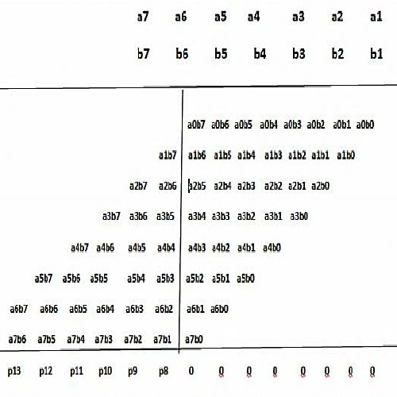
Fig 3.1: Partial product matrix of an 8-bit multiplier

Multiplication involves mainly 3 steps:
• Partial Product Generation
• Partial product reduction schemes to two rows
• Final addition of two rows of partial product by using a carry propagate adder.

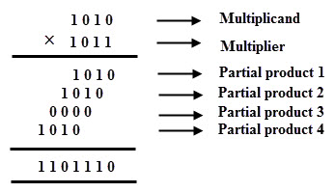.
Fig 3.2: Final addition of two rows of partial product

WORK ON TRUNCATED MULTIPLIER

A multiplier is used to multiply two images on a pixel-by-pixel basis, thus combination the two images into a single output image. It shows two examples: both input images and the resulting output image are provided.The average NED and the peak signal-to-noise ratio that is based on the mean squared error (MSE) are computed to evaluate the quality of the output image and compare it with the output image generated by a literal multiplier.In proposed architecture we can multiply 8x8 bits, and the bits are reduced in step-by-step manner. Then the number of stages to reduce the final bit width is without increasing the error. In normal truncated multiplier design, the architecture produces the output with some truncation error. But in the proposed design of truncated multiplier the truncation error is not more than 1, so the precision of the final result is improved. It shows proposed truncated multiplier.We implemented 8-bit multiplier reduces the partial product array due to which the area is minimized. This reduction in partial product increases the speed of the multiplier. The proposed multiplier is designed and implemented using ALTERA STARTER and analysed 6.4a and XILINX Vivado ISE version 14.7. The desire is to present a virtual study of the standard and truncated 8x8 multipliers. The truncated multiplier as compared to standard multiplier shows much more reduction in device utilization.

CHAPTER 4
RESULTS AND DICUSSION
For functional verification, the multiplier designs are simulated by using of VHDL language in XILINX Vivado ISE version 14.7 tool. These multipliers are synthesized by using the Design Compiler with 90nm CMOS standard cell technology library. The synthesized area and delay reports are given in
Table 4.1.
Table 4.1: Device Utilization Summary

Device Utilization Summary (estimated values) |  |  | [-]
Logic Utilization | Used | Available | Utilization
Number of Slice LUTs | 18 | 63400 | 0%
Number of fully used LUT-FF pairs | 0 | 18 | 0%
Number of bonded IOBs | 16 | 210 | 7%

Minimum period: No path found
Minimum input arrival time before clock: No path found
Maximum output required time after clock: No path found
Maximum combinational path delay: 2.676ns

Total REAL time to Xst completion: 1.00 secs
Total CPU time to Xst completion: 0.33 secs
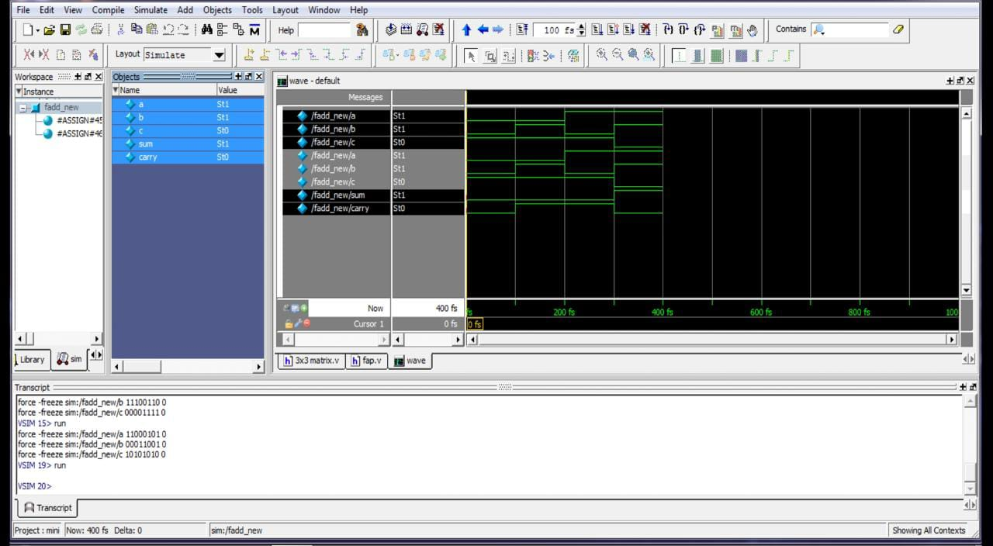Fig 4.1: Result

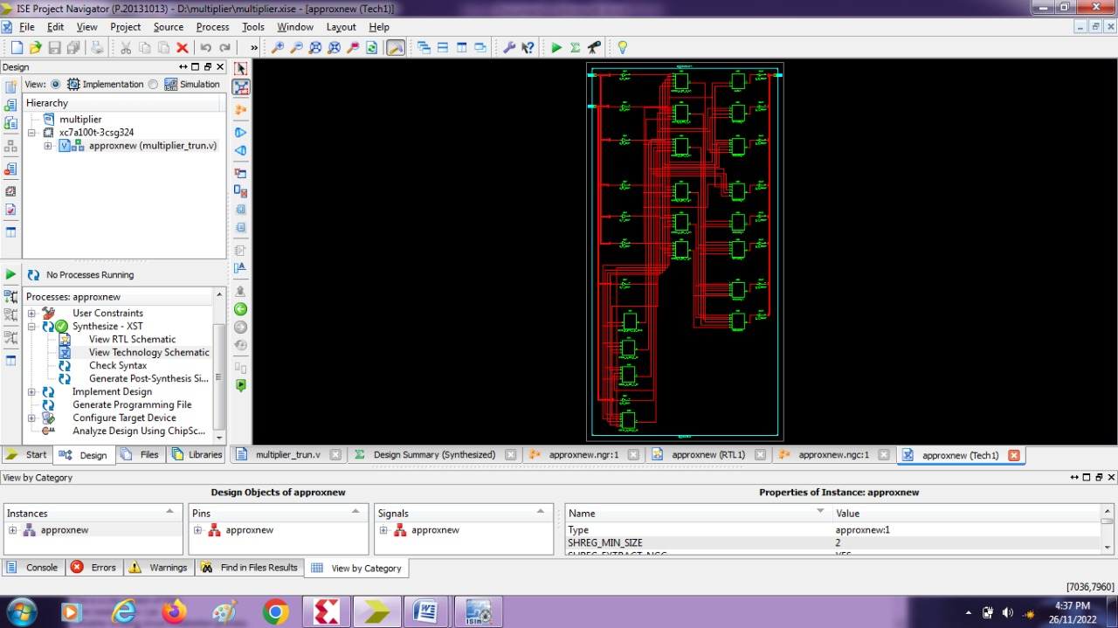
Fig 4.2-RTL schematics of proposed multiplier

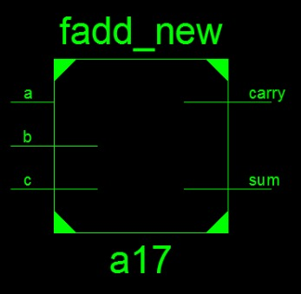

Fig 4.3. Fadd_new schematics multiplier

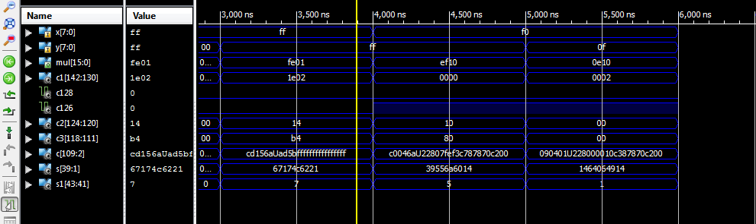

Fig 4.4. Analysis of truncated multiplier

CHAPTER 5
CONCLUSION

In this paper, a high speed and power efficient run time configurable Truncated multiplier has been proposed. It provides a smaller number of active logic gates during computation process. The input redundant bits are efficiently detected and deactivated unwanted computation, thereby reducing computation time due to less active logic gates. It can reduce power consumption by the logic gates. In case of full-length input data computation area overhead occur due to the detector block. But in real time applications at least 50% of input data lies in half-length redundant bit, if N is greater than 8. As a result, overall system performance will improve. So, the proposed run time configurable detector unit based truncated multiplier is suitable for high-speed image applications.

REFERENCES
- H. Xiao, H. Xu, X. Chen, Y. Wang, and Y. Han, ‘‘Fast and high-accuracy approximate MAC unit design for CNN computing,’’ IEEE Embedded Syst. Lett., early access, Dec. 21, 2021, doi: 10.1109/LES.2021.3137335
- S. Venkatachalam, E. Adams, H. J. Lee, and S. Ko, “Design and analysis of area and power efficient approximate booth multipliers,” IEEE Trans. Comput., vol. 68, no. 11, pp. 1697–1703, Nov. 2019.
- M. Ha and S. Lee, ‘‘Multipliers with approximate 4-2 compressors and error recovery modules,’’ IEEE Embedded Syst. Lett., vol. 10, no. 1, pp. 6–9, Mar. 2018.
- J. Liang, J. Han, and F. Lombardi, "New metrics for the reliability of approximate and probabilistic adders,” IEEE Transactionson Computers, vol. 62, pp. 1760-1771, 2013
- S. Ullah, H. Schmidl, S. S. Sahoo, S. Rehman, and A. Kumar, “Area optimized accurate and approximate softcore signed multiplier architectures,” IEEE Trans. Comput., vol. 70, no. 3, pp. 384–392, Mar. 2021,doi: 10.1109/TC.2020.2988404.
- Felzmann, J. F. Filho, and L. Wanner, “Risk-5: Controlled approximations for RISC-V,” IEEE Trans. Comput. -Aided Design Integr. CircuitsSyst., vol. 39, no. 11, pp. 4052–4063, Nov.2020.
- G. Lentaris, G. Chatzitsompanis, V. Leon, K. Pekmestzi, and D. Soudris, “Combining arithmetic approximation techniques for improved CNN circuit design,” in Proc. 27th IEEE Int. Conf. Electron. Circuits Syst.(ICECS), 2020.
- P. J. Edavoor, S. Raveendran, and A. D. Rahulkar, ‘‘Approximate multiplier design using novel dual-stage 4:2 compressors,’’ IEEE Access, vol. pp. 48337–48351, 2020.
- Qiqieh, R. Shafik, G. Tarawneh, D. Sokolov, S. Das, and A. Yakovlev, ‘Significance-driven logic compression for energy-efficient multiplier design,’’ IEEE J. Emerg. Sel. Topics Circuits Syst., vol. 8, no. 3, pp. 417–430, Sep. 2018.
- W. Liu, L. Qian, C. Wang, H. Jiang, J. Han, and F. Lombardi, “Design of approximate radix-4 booth multipliers for error-tolerant computing,” IEEE Trans. Comput., vol. 66, no. 8, pp. 1435–1441, Aug. 2017.

PUBLICATION
National Conference
DR.K.Sivanandam, R.Janapriya,R.Karthika,G.Monika,“HighPerformance Truncated Multiplier For Image Processing Application”,Second National Conference of Recent Innovation in Mechanical Engineering (RIME`2k22),ISBN978-8-19-551315-4.

